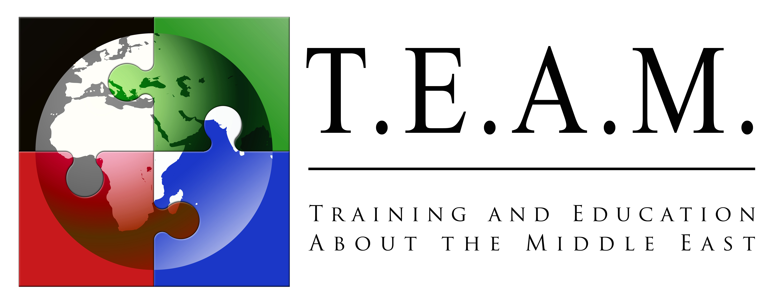

Training and Education About the Middle East

and

The Arthur and Sophie Brody Foundation Distinguished Israeli Speakers Series
present
"Myths and realities of life in the disputed territories"
By Raphaella Segal, Assistant Mayor of Kedumim (in the West Bank)
February 28, 2012, 7:00 pm at the Astor Judaica Library
Lawrence Family JCC Jacobs Family Campus - 4126 Executive Dr. – La Jolla, CA 92037
FREE ADMISSION
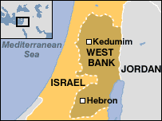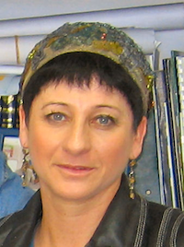
Raphaella Segal is a founding member and currrent Assistant Mayor of Kedumim, an Israeli settlement located in the Samarian hills of the West Bank. Founded in 1975 by members of the Gush Emunim settlement movement, its current population today numbers about 3,500 people. The international community considers Israeli settlements in the West Bank illegal under international law, an interpretation disputed by the Israeli government.
Born in South Africa in 1953, Raphaella Segal came to Israel as a young child. She and her husband Avi joined the pioneers who established Kedumim in 1975, and moved into a 24-square meter mobile home with the first group of families settling on what were then nothing more than barren hilltops. The physical challenges of those early years should not be underestimated - electricity, water and heat could not be taken for granted. Over the years, the families moved from tiny mobile homes to small pre-fab housing, and finally to private homes.

In her presentation, Raphaella will emphasize the historic roots of Kedumim and its strategic importance to Israel's security. Ancient and modern converge as Raphaella demonstrates history in the making and how "facts on the ground" can determine the future of the Jewish State. A mother of 9, Raphaella is an optometrist and vision specialist at the Schneider Hospital in Petach Tikva, and runs a private eye clinic in Tel Aviv.

Co-sponsored by the Zionist Organization of America - San Diego District

